Photosystem II Function under Extreme Low Light and Low Temperatures in Polar vs. Temperate Phytoplankton
Chlamydomonas species:
- Polar, saline
  - C. priscui: Antarctic, Lake Bonney, 17 m below the surface
  - C. sp. ICE-MDV: Antarctic, Lake Bonney, various depths including surface
  - C. malina: Arctic, Beaufort Sea, various depths
- Polar, freshwater
  - C. klinobasis: Arctic, Svalbard Island, snow alga
- Temperate, saline
  - C. euryale: Pacific Ocean (but also various other locations)
- Temperate, freshwater
  - C. reinhardtii: various locations, soil
Experiment plans:
All algae will be cultured at low light intensity (10 μE) under continuous full-spectrum LED light, in Pyrex tubes with air bubbling in temperature-regulated aquaria. All algae grow well under these conditions (different growth rates) and have >10% cell death. The low salinity for the marine species also overlaps with the high salinity for the freshwater.
# samples = 6 species x 3 salinities = 18 (4 have already been done, green)
 |  |  | Salinity (mM NaCl)
Habitat | Species | Temp (°C) | Low | Medium | High
Saline | C. priscui | 4 | 30 | 70 | 500
 | C. sp. ICE-MDV | 4 | 30 | 70 | 500
 | C. malina | 4 | 30 | 70 | 500
 | C. euryale | 24 | 30 | 70 | 500
Freshwater | C. klinobasis | 4 | 0.43 | 10 | 30
 | C. reinhardtii | 24 | 0.43 | 10 | 30
Questions:
- C. euryale is the only species that requires ammonia as a nitrogen source, all others use nitrate. Is this an issue? Ammonia may have PSII effects as higher concentrations, but should be fine. May be a discussion point.
- Do we need to repeat the conditions that are already done (in green?) Lower priority, but have cultures just in case (or omit if there’s no space)
- How many biological (tubes) and technical repeats (repeats on the same tube)? Triplicate tubes if possible would be great
  - If we do everything once – 18 samples
  - Omitting measurements already done once (green) – 14 samples
- Is there value in including ICE-MDV in the measurements? Are there too many samples, logistically? Keep ICE-MDV and make it the last sample, if there is time
- What should we measure on our end? OD, [Chl], %cell death – anything else? Growth rates
- To test below 0C or 2C, to grow them at 4 but transfer at lower temp for the measurements. The machine has to be connected to the water bath, has a jacketed curve. Mackenzie will test.

Some preliminary growth curves
C. klinobasis (Fv/Fm, OD750) C. malina (OD750)
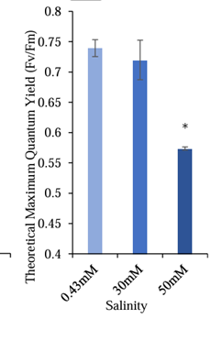

C. euryale

